**Scripture and Feast Day Notes**

**Fifth Sunday after Theophany**

**From Today’s Readings**

**John 6:22-38** There is something almost comical about the initial verses – people only a short time ago miraculously fed with thousands of loaves and fish now look for the whereabouts of Jesus and His disciples. When they find Jesus on the far shore and ask what they must *do* to please God, His answer is simple: believe in the one He has sent. “I am the bread of life” He goes on to say. “He who comes to me will never hunger again.” *Discuss/reflect: “Ingesting” the word of God is a recurring theme in Scripture. Ezekiel (Ezekiel 3:3) is handed a scroll by God and told to eat it; an angel directs John (Revelation 10:9) to do the same; this is all about taking what is “outside” and making it part of the “inside” of you - more about “being” than “doing.” Are you there yet with Jesus?*

**2 Tim 3:1-12** St. Paul details the godless behavior of the end-times – a variety of timeless evils we can certainly relate to today: pride, greed, self-absorption, lack of love, boastfulness. You could check each off in today’s headlines and social media. (In v. 8, the reference is to two duplicitous Egyptian court magicians at the time of Moses). It will be tough following Christ and what is True and Right, but in Him lies rescue and reprieve. *Discuss/reflect: In verse 7 we read about people who are: “always learning but never able to acknowledge the truth.” In what ways might you too be “always learning” about Jesus, but not living out His Truth?*

**Is 63:7-18**  In a psalm of trust and praise, regret and repentance, Isaiah speaks on behalf of a people who are grounded in the memories of God’s goodness. His “many kindnesses” (v 7) prompt them to ask once again for His mercy and intervention: “Return for the sake of your servants.” (v 17) *Discuss/reflect: Where in your life do you wish God would* do *something?*

**Tomorrow is February 14: The Presentation of the Lord *(Dyarnuntarach*)/Valentine’s Day**

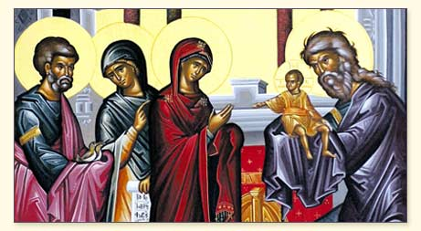

Joseph and Mary took the infant Jesus to be presented at the Temple in Jerusalem. There they met two devout people, Simeon and Anna, who had been waiting patiently to encounter the Messiah. (See Luke 2:22-40 for the full account.)

In an early Armenian custom associated with this feast, worshippers would light candles during the evening church service, carry the flame out into the night (symbolically bringing light into the void), and take it home for their lamps as well as light a bonfire in the church courtyard. The festivities included leaping over the fire; newlywed women would step over it to scorch their skirts in an appeal for fertility. *Valentine’s Day* has Christian origins! Valentine was a priest in the 3rd century, imprisoned for marrying a couple at a time when marriage was forbidden to young men capable of being soldiers. While imprisoned, the priest (priests were allowed to marry at that time) and the jailor’s daughter fell deeply in love. And when Valentine was taken away to be executed, he sent her a farewell letter signed “from your Valentine,” words that continue to echo in today’s Valentine’s cards to loved ones. *Reflec-*

*tion: How is love demonstrated by each person associated with The Presentation?*

*Department of Christian Education/ Diocese of the Armenian Church (Eastern)/*[*elisea@armeniandiocese.org*](mailto:elisea@armeniandiocese.org)