Resources and activities about FRIENDSHIP
YOUTUBE
Teen voices: Friendship and Boundaries 5:04 minutes
https://youtu.be/yjzGxLq1Dqs

This is how to build healthy friendships for teenagers
https://youtu.be/C34gFc-C4Y0 20:55

Friends-friendships-what is a quality friendship and why
https://youtu.be/bNzFPPMnF1Y 3:44

5 ways to make MORE friends in High School
https://youtu.be/cGmX4fzu2lI 5:17

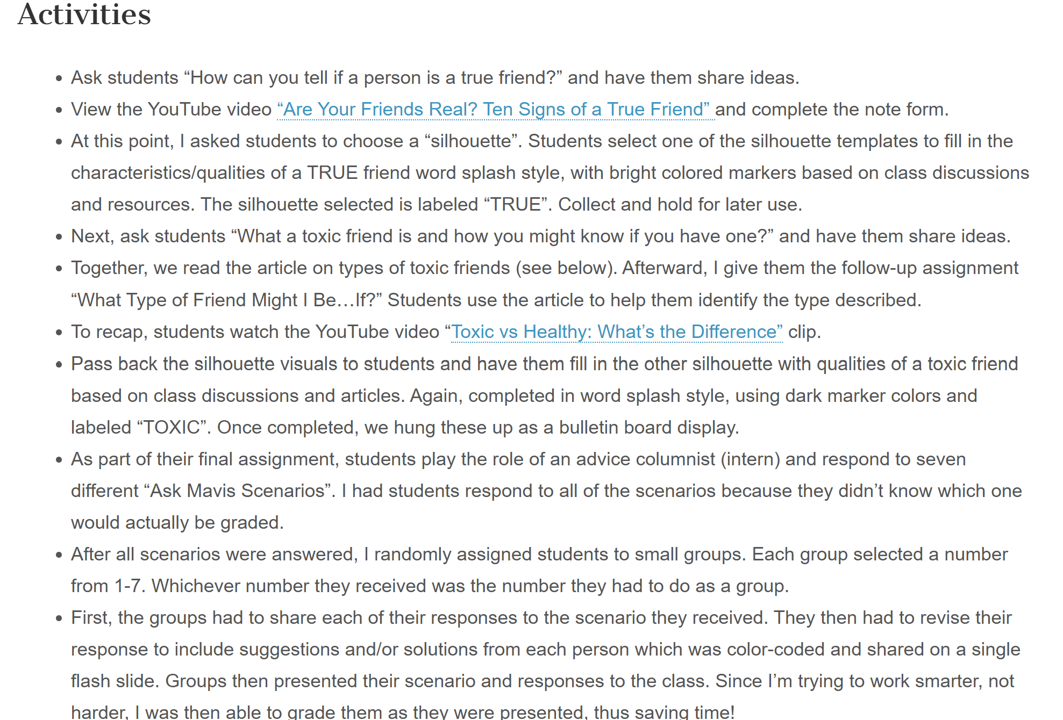
From FamilyConsumerSciences.com

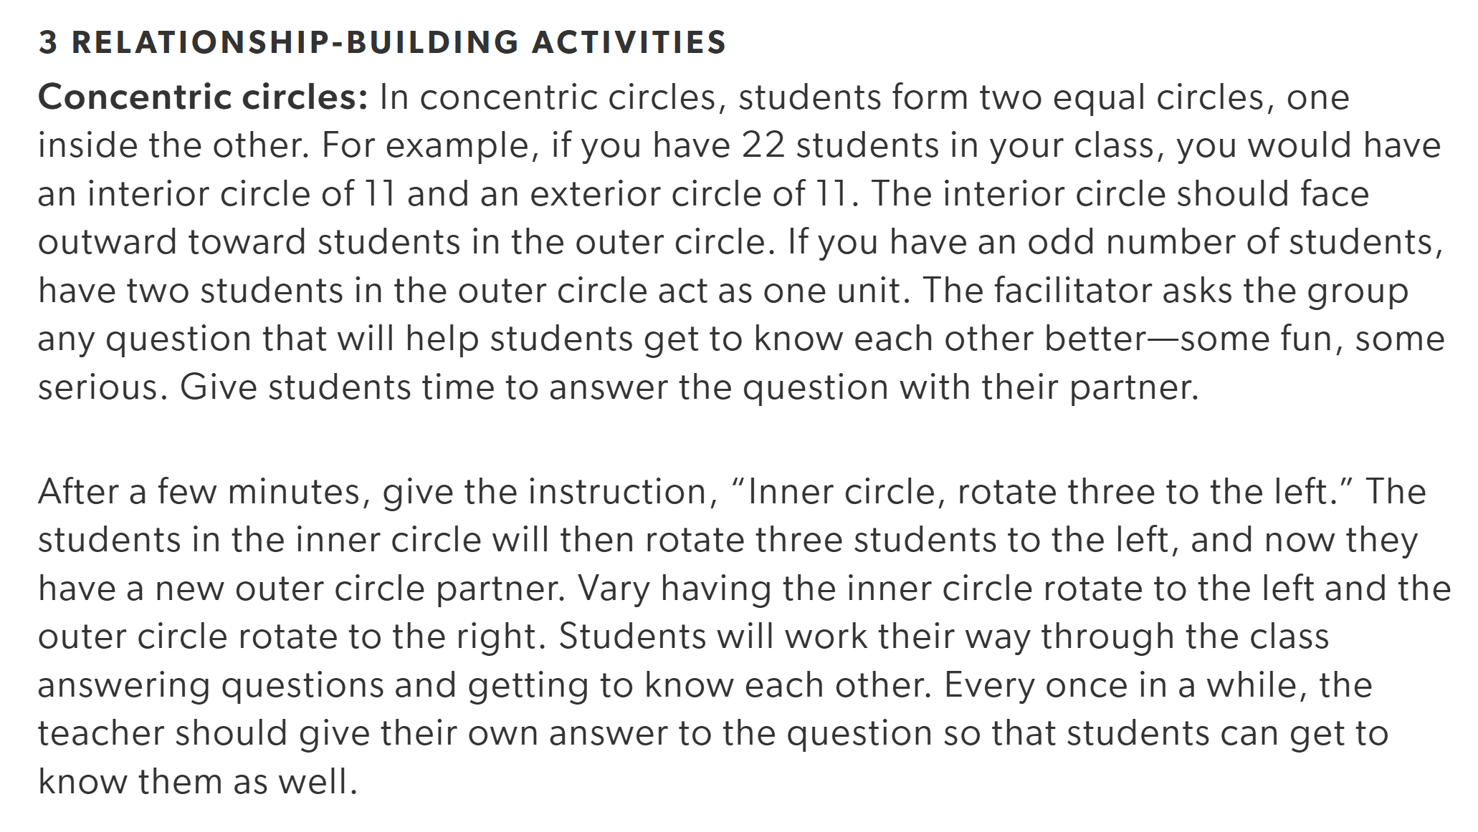
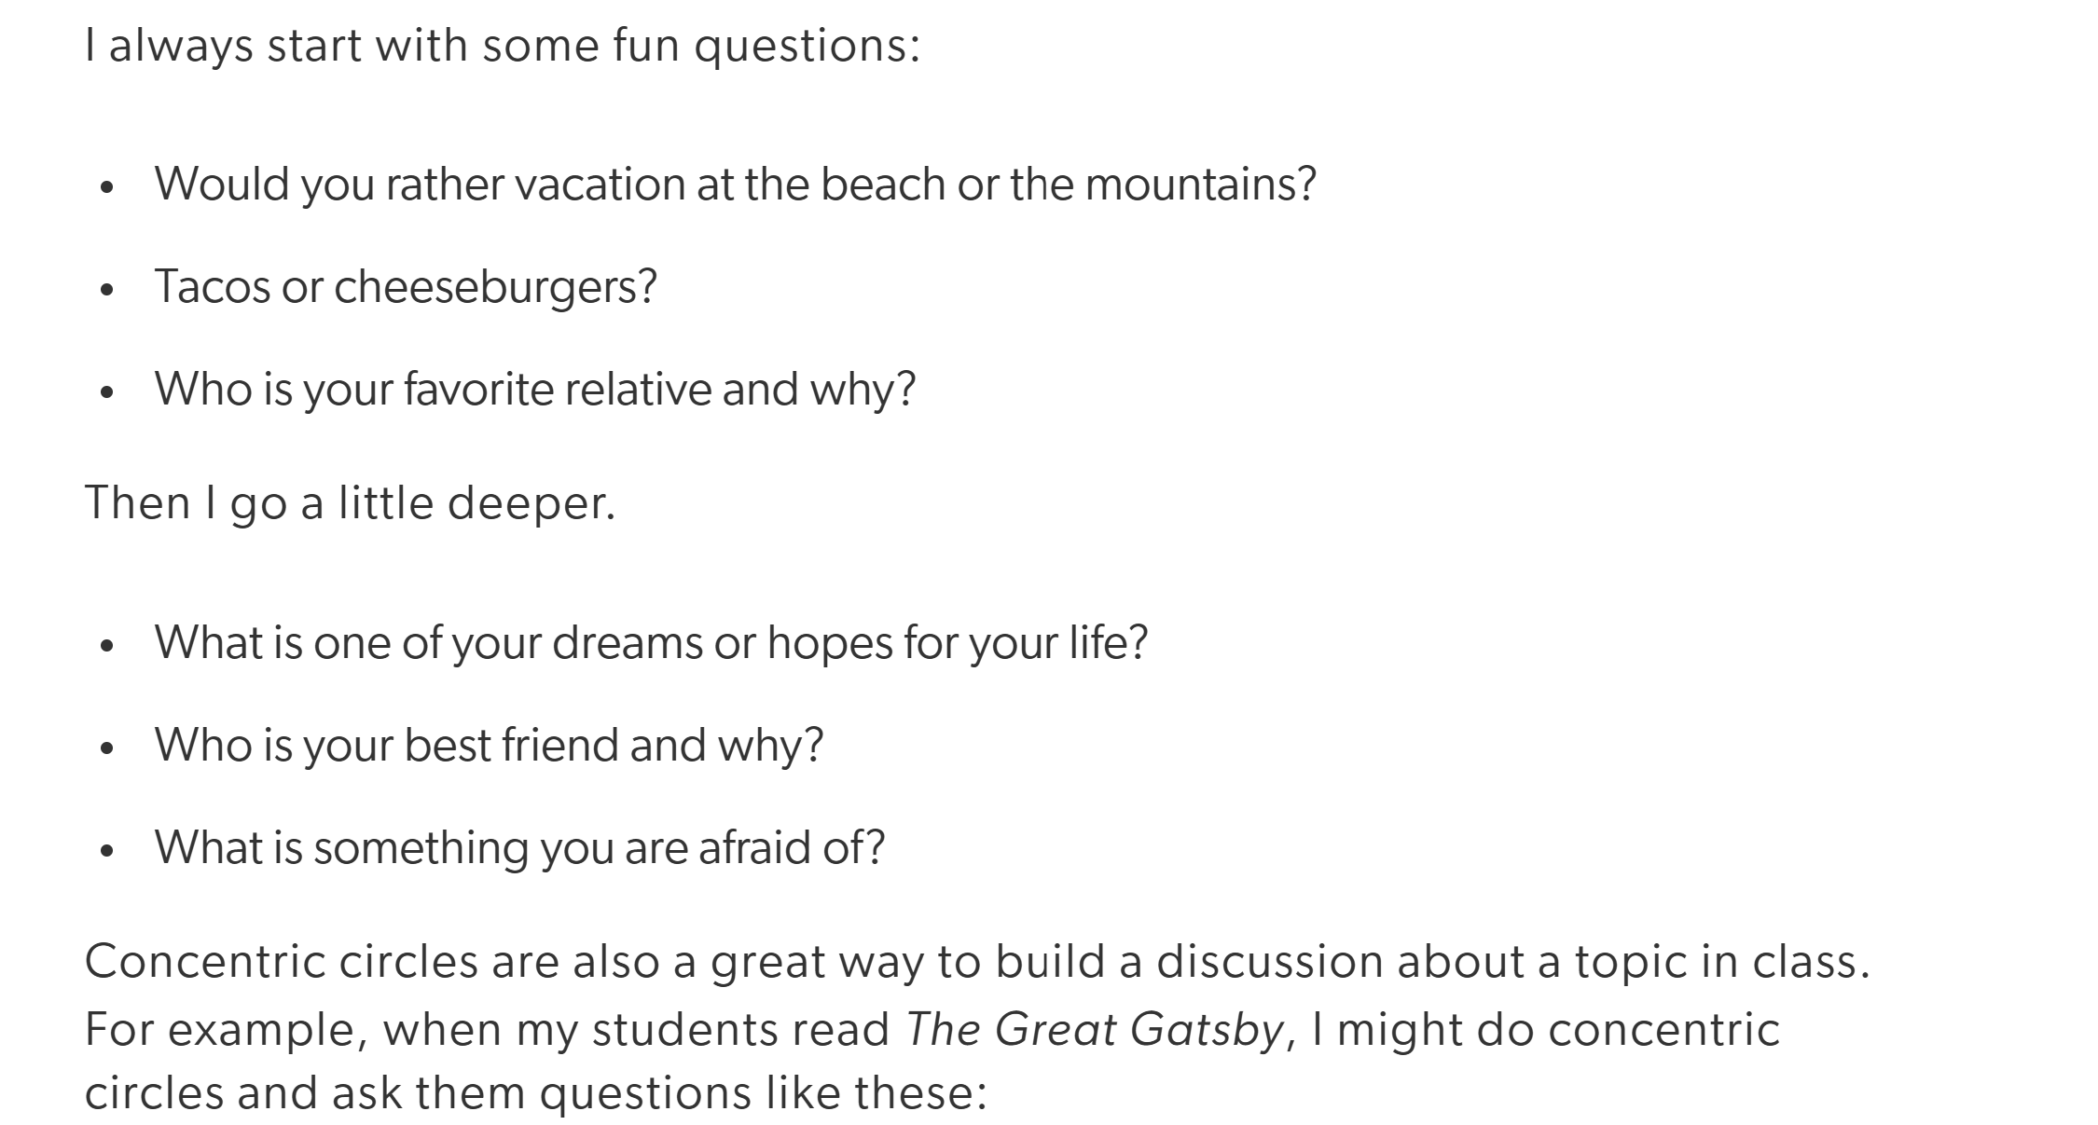
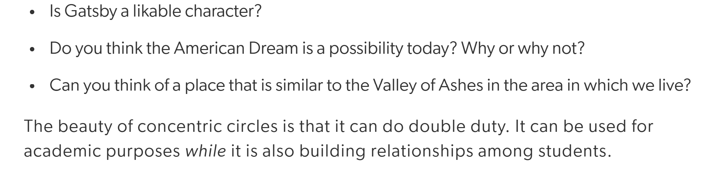

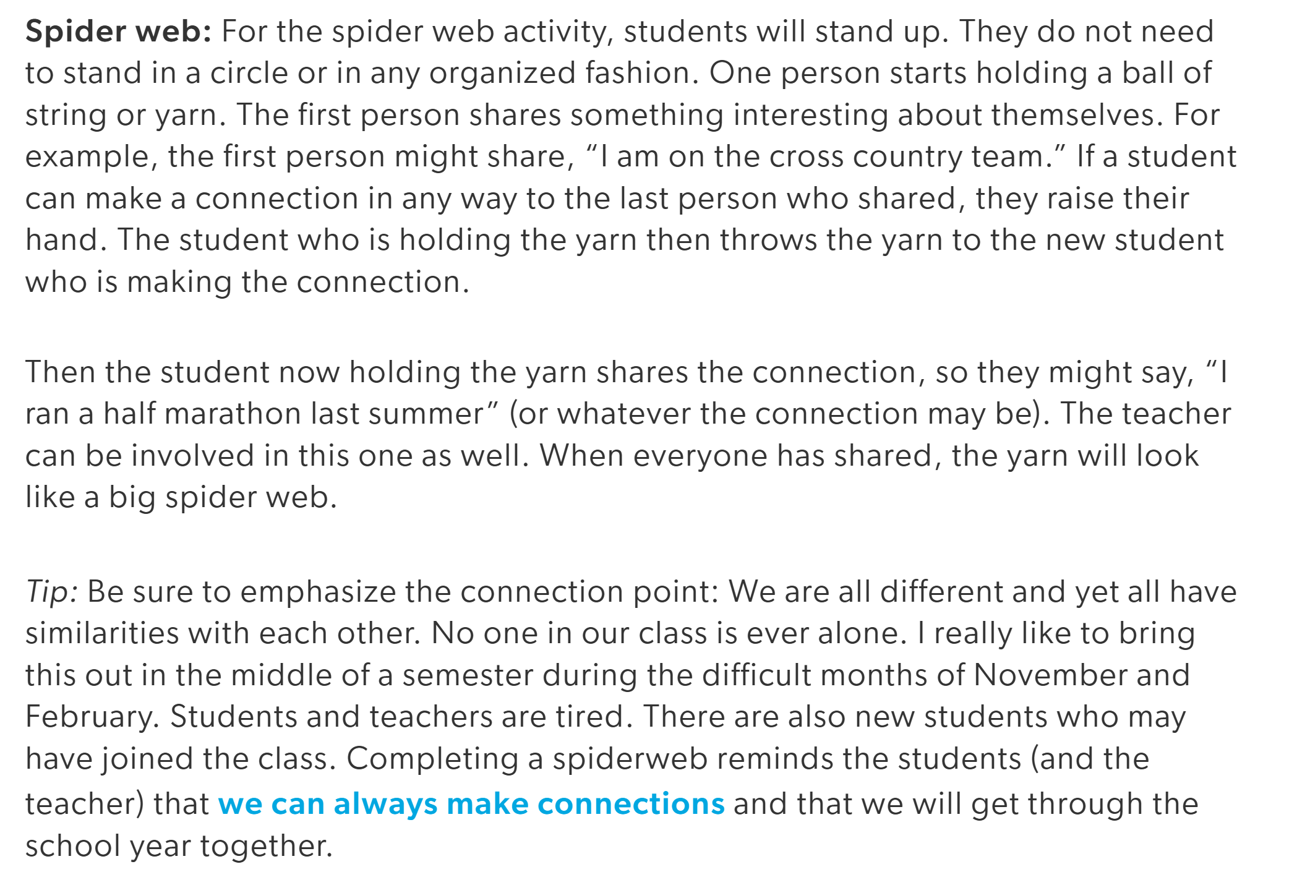
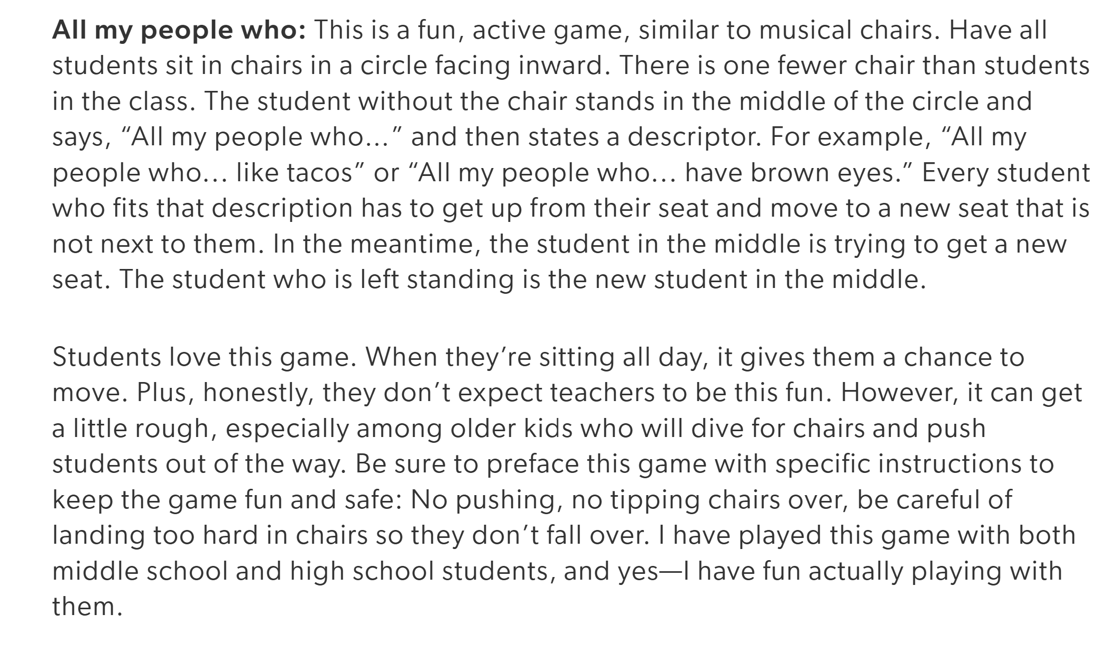
From Edutopia.org

