
Old We Believe Grade 10 1.1

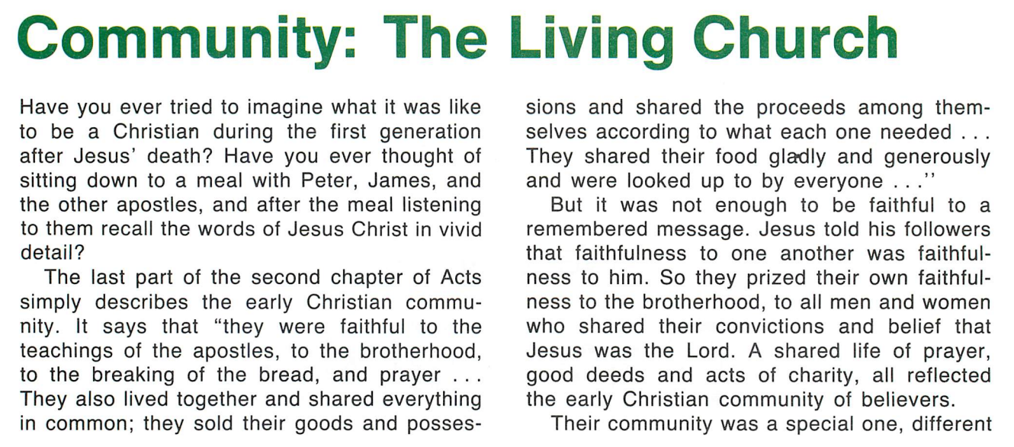

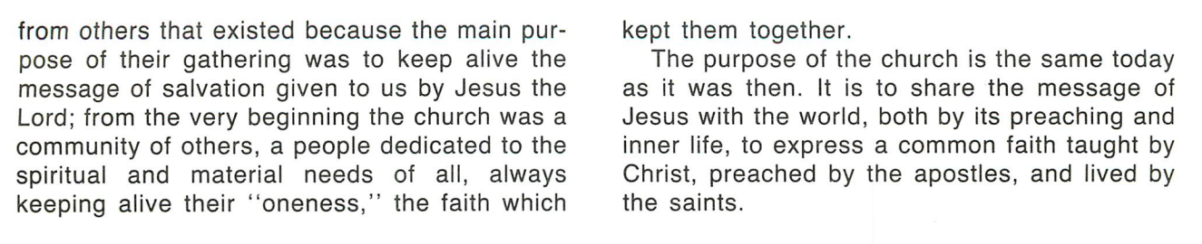

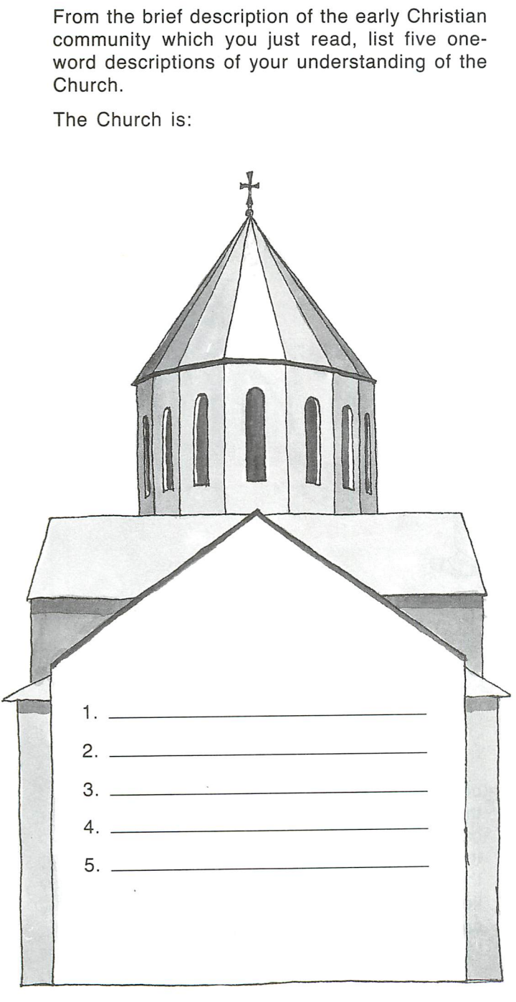
Read the following scripture readings, what do they each say about the church:

Matthew 26:26

Romans 12:5

I Corinthians 12:12-28

DEFINE THESE WORDS:

One- (Meg)

Holy- (Soorp)

Catholic- (Untanragan)

Apostolic- (Arakelagan)

