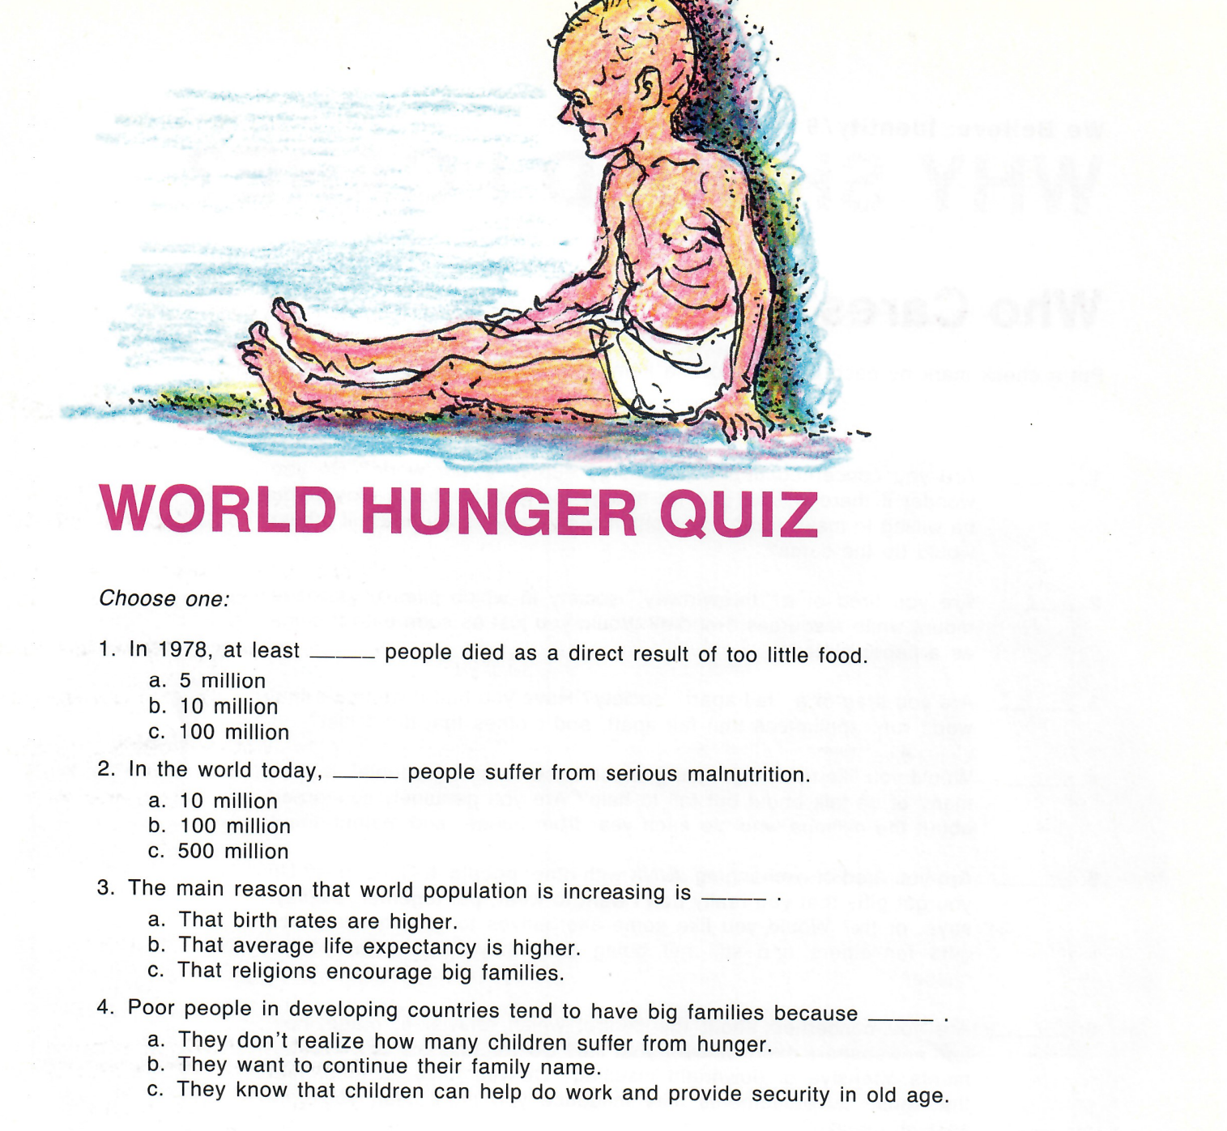
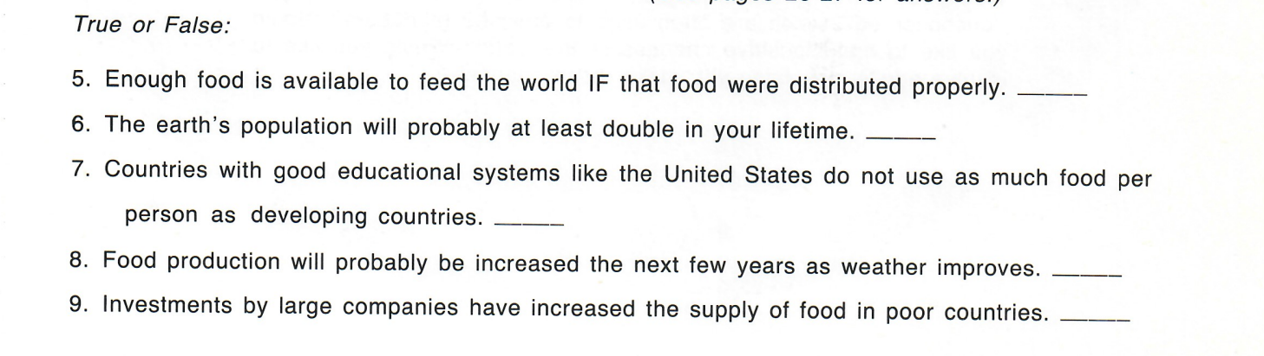

Activity for Old We Believe Grade 11 Minilesson 1-6

