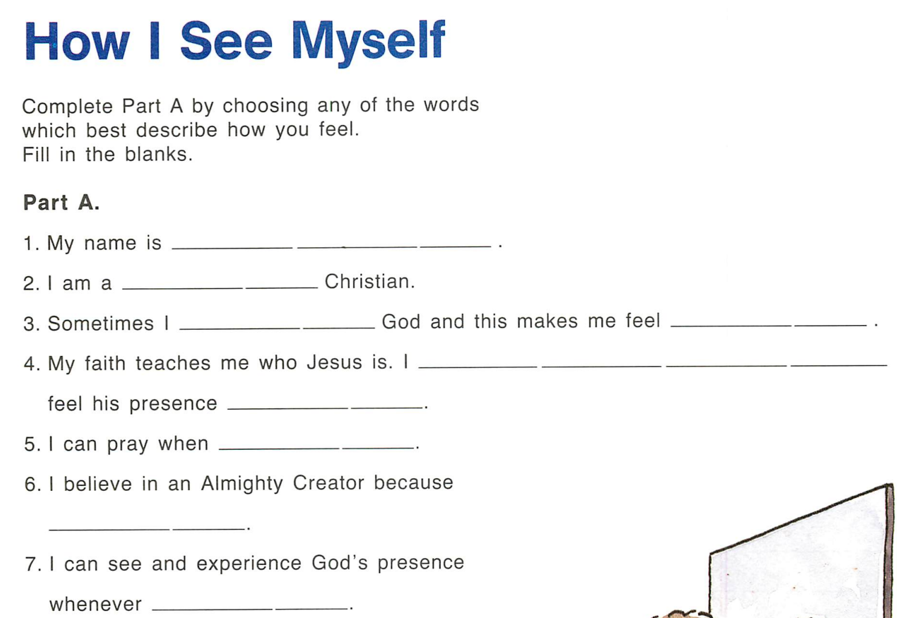
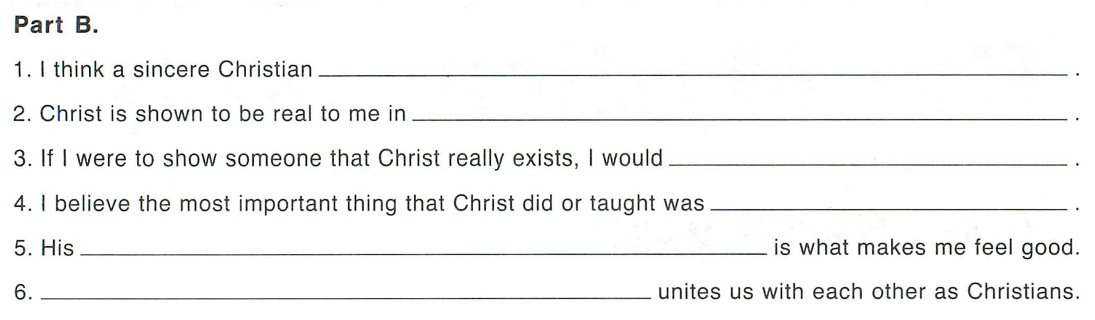

Old We Believe Gade 10 8.1
Now read the following Scripture passages:
John 20:19-22
Matthew 28:16-20
Acts 2:1-4
From these biblical passages, what would you say about the Church as the mystical body of Christ? List some ways that, through the power of the Holy Spirit, the mystical body of Christ, the Church, takes form and action.

