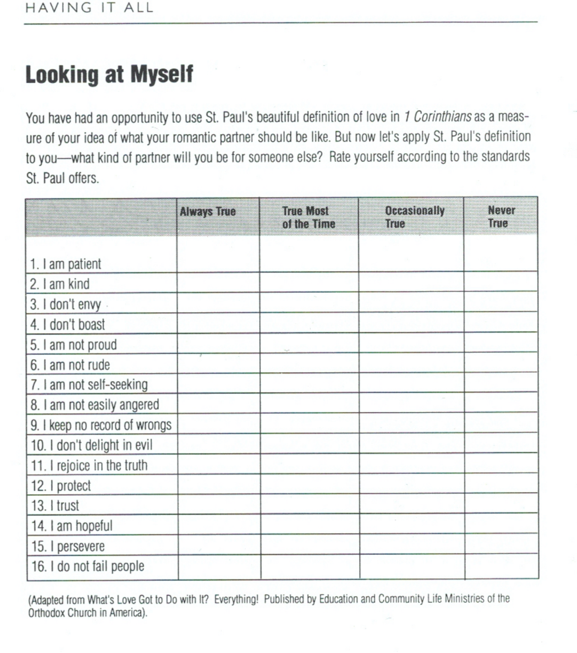
Lesson 3 Love and Commitment

