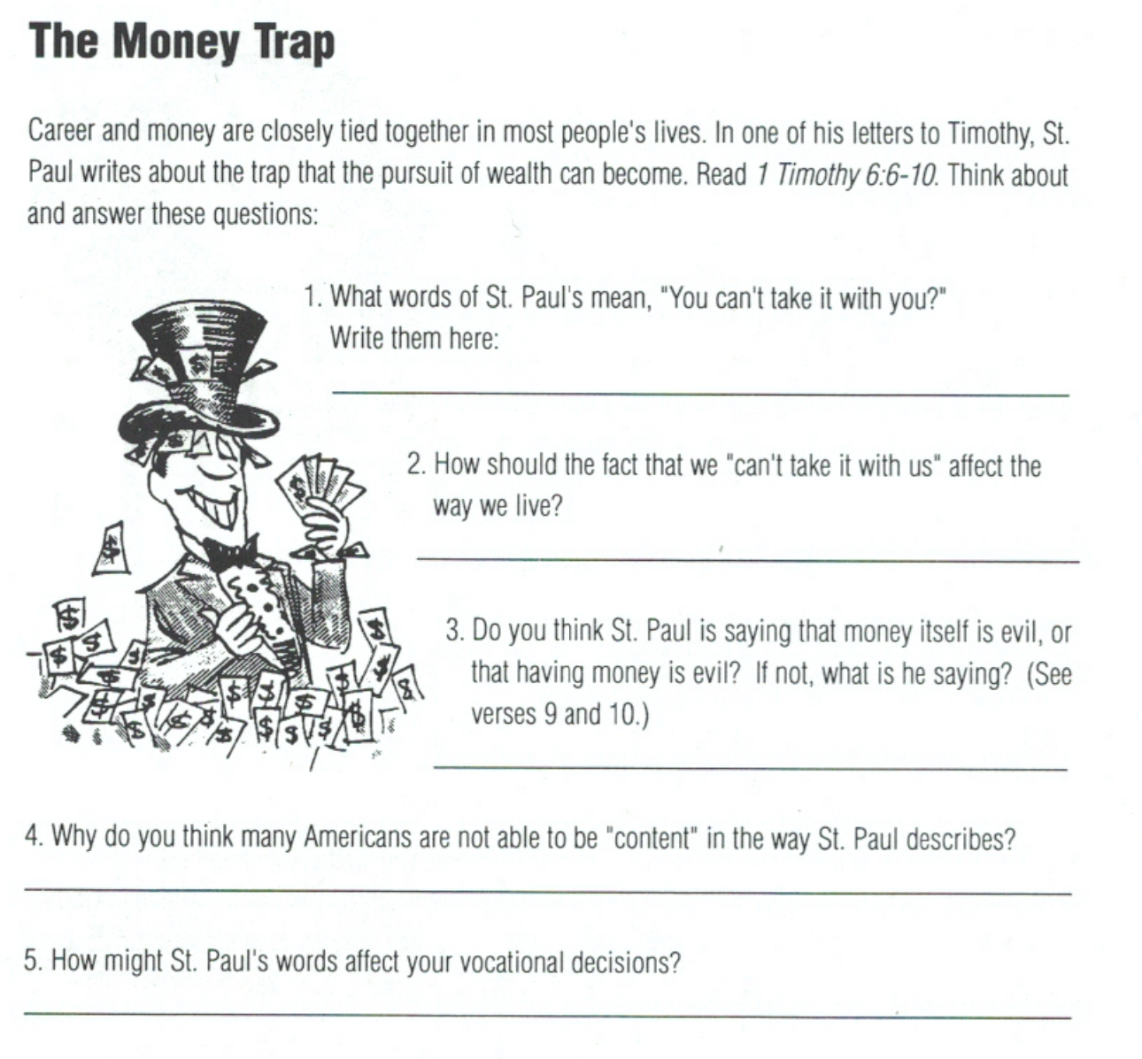

Having It All Lesson 5 Vocations

