**Sunday School Teachers’ Scripture and Feast Day Weekly Memo**

**Easter Sunday**

**From Today’s Readings**

**Mark 16:2-8** *Early on Sunday, Mary Magdalene, Mary (James’ mother), and Salome are on their way to Jesus’ tomb with spices to anoint His body. They debate whether they would be able to move the heavy stone that sealed the tomb.* (What a tender, human moment!) *To their surprise, the stone had been rolled away and an angelic figure sits inside the tomb, proclaiming Jesus’ resurrection. They were to tell the disciples and seek the Lord in Galilee.* Discussion: These women had been with Jesus even at His crucifixion, among many other women who had “followed him and cared for his needs.” (Mark 15: 40-41) What does this tell you about the faith of these women? What does this, joined with all the other Gospel stories featuring women, tell us about their role then and now as Christian witnesses?

**Acts 1:15-26** *Having encountered Jesus after His crucifixion and witnessed His ascension,**Peter is addressing the believers, sharing the grim details of Judas’ death. He then declares that a new apostle is needed to replace the betrayer and outlines his qualifications.* Discussion: Read vv 21-22 closely. What should qualify this new apostle? (that he have been with the Lord the entire time, day in and out, and that he would be able to witness to His resurrection) What might this mean for us as Jesus’ followers today?

**John 20:1-18 ( Matins/Vespers Gospel)** *The disciples had gone, but Mary Magdalene is still grieving over her beloved Lord’s tomb Two angels ask her why she is crying and when she responds that she does not know where her Lord’s body is, she is suddenly surprised by someone she mistakenly thinks is the gardner. It is Jesus, yet only when He calls her by name does she know Him. ‘Teacher!’ she answers ecstatically. He asks her to tell the disciples about their meeting; she runs to them with the words “I have seen the Lord!”* Discussion: Mary meets the risen Lord and thinks he is the gardner. What famous garden is featured in Genesis 1,2, and 3? In what garden did Jesus sweat so profusely in prayer that they were described as drops of blood? How has Creation come full circle in the risen Lord?

***Kreesdos haryav ee merelotz! Christ is risen from the dead!***

***Orhnyal eh harootiunun Kreesdosee! Blessed is the Resurrection of Christ!***

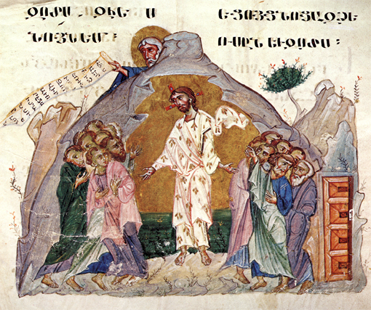

*Department of Christian Education*/*Diocese of the Armenian Church of America (Eastern)*/[*elisea@armeniandiocese.org*](mailto:elisea@armeniandiocese.org%0d%20%20ericv@armeniandiocese.org)