God Chooses David to be King
1 Samuel 16

Main Point: God uses people who have a heart that trusts in Him.

Key Verse: “Man looks at how someone appears on the outside. But I look at what is in the heart.” 1 Samuel 16:7b

Craft Ideas
“God Chooses David” Picture
Supplies Needed: copies of the shepherd David picture, crayons or colored pencils, sheep stickers or die cut shapes, cotton balls for clouds.
- Connect picture of David, dot-to-dot.
- Color picture, using crayons and/or colored pencils.
- Apply sheep to picture, and cotton balls to clouds, using glue sticks.
- Print Key Verse and Main Point onto sticker address labels, Avery #5160 and apply to colored picture.

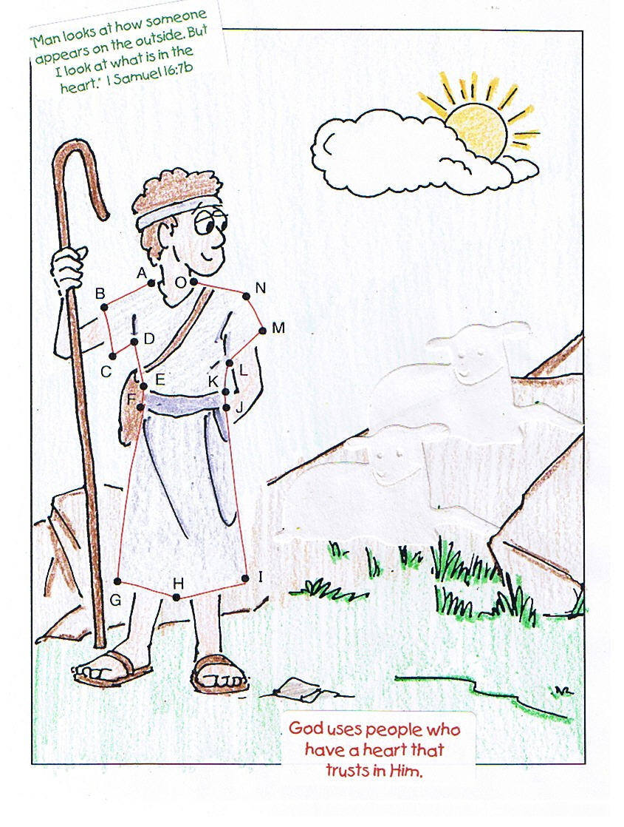

“My Heart Trusts in God” Key Chain
12 Design Your Own! Heart-Shaped Key Chains,
www.orientaltrading.com, #57/6324
- Snap apart heart key chain.
- Decorate heart insert, using markers or colored pencils.
- Print Key Verse onto sticker address labels, Avery #5167 and apply to decorated insert.
- Place heart insert back into key chain and snap back together.
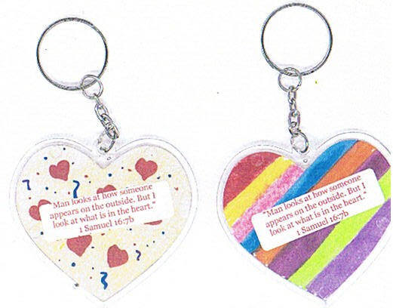

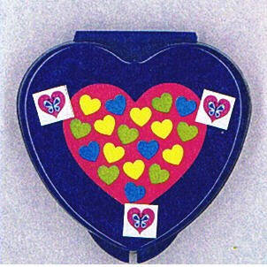
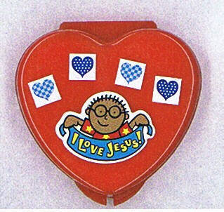
Alternative Heart Craft, www.orientaltrading.com, 32/754, with stickers 12/1885

